**10-24 notes**

Project 1

Goals:

By the end of this lesson, you will be able to:

* Articulate the requirements for Project 1.
* Draw and interpret diagrams of Git branching workflows.
* Create new branches with Git.
* Push local branches to GitHub.

**Project requirements:**

Demonstrate a thorough understanding of everything we’ve learned so far.

* Data manipulation
* Statistics (linear regression, mean, median, mode, outliers)
* Visualization (Graphs, Scatter plot, maps maybe too?)
  + 6-8 visuals for full credit
* Short analysis
  + What were the findings/results?
    - Why is each result significant?
  + What other factors could be at play or skewing the data?
  + Shortcomings of the data?
  + What further analysis could be done?

Send TAs or Manish a project proposal.

**Presentation:**

Make a slideshow with:

* Hypothesis
* Exploratory Data Analysis
* Tests that were ran and results (visualizations)
* Data sources
* Challenges we faced during the process
  + Data Wrangling

Open the floor for questions

Cite sources

**10 minute presentation including:**

* Questions that you found interesting and what motivated you to answer them
* Where and how you found the data you used to answer these questions
* The data exploration and cleanup process (accompanied by your Jupyter notebook)
* The analysis process (accompanied by your Jupyter notebook)
* Your conclusions, including a numerical summary and visualizations of the summary
* The implications of your findings: what do your findings mean?

**Development requirements:**

* Use Pandas to clean and format your dataset or datasets.
* Create a Jupyter notebook **describing the data exploration and cleanup** process.
* Create a Jupyter notebook **illustrating the final data analysis**.
* Use Matplotlib to create 6 to 8 visualizations of your data
* (ideally, at least 2 visualizations per “question” that you ask your data).
* Save PNG images of your visualizations to distribute to the class and instructional team—and for
* inclusion in your presentation.
* Create a write-up summarizing your major findings. This should include a heading for each “question”
* that you asked your data as well as a short description of your findings and any relevant plots.
* **Bonus** Use at least one API—if you can find one with data pertinent to your primary research questions.

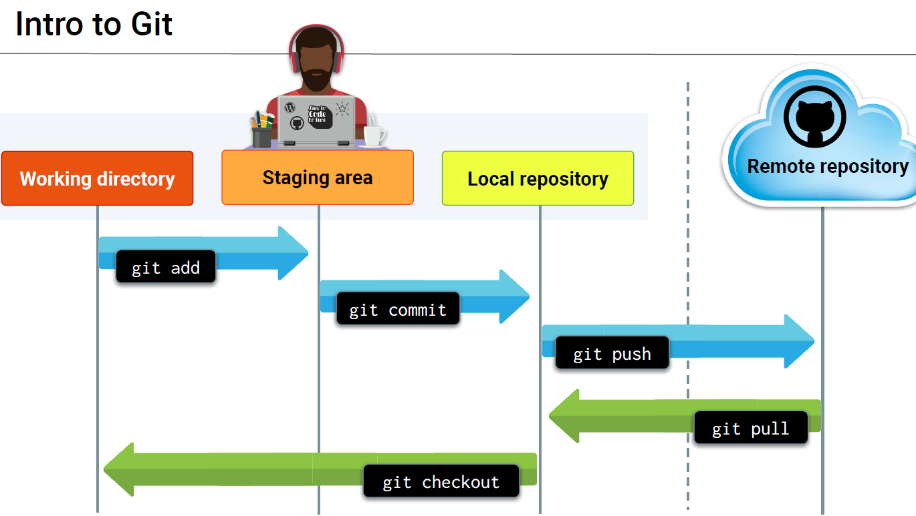

**Code to put in command prompt after navigating to proper folder/cloned repo on computer**

git clone https://github.com/KetzaMeradin/Repository_Name.git

git add "test.py" or git add .

git status

git commit -m "my first file"

git push

**Bug Fixing/Patches:**

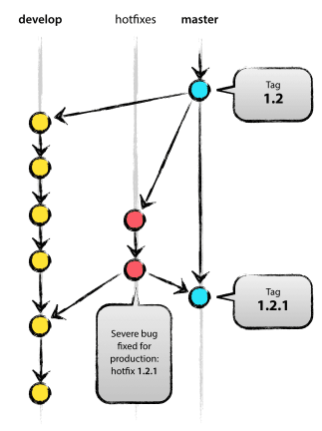

**Real world:**

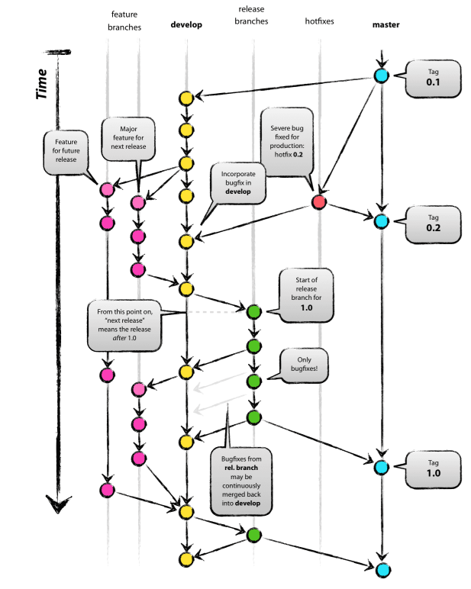

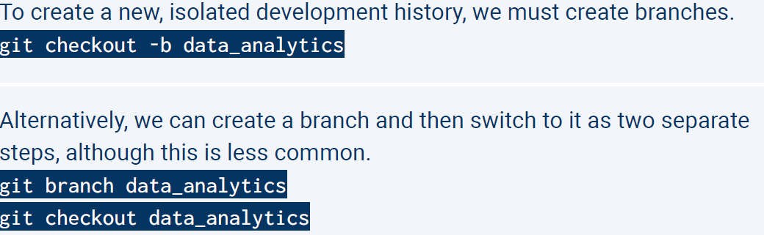

^ Top code is making the branch and checking it out all in one line of code

